Jeremiah Richard
CSE 4344-002
3/26/2023
ID: 1001475742

Project II
Questions 1-7
http://gaia.cs.umass.edu/wireshark-labs/HTTP-wireshark-file1.html

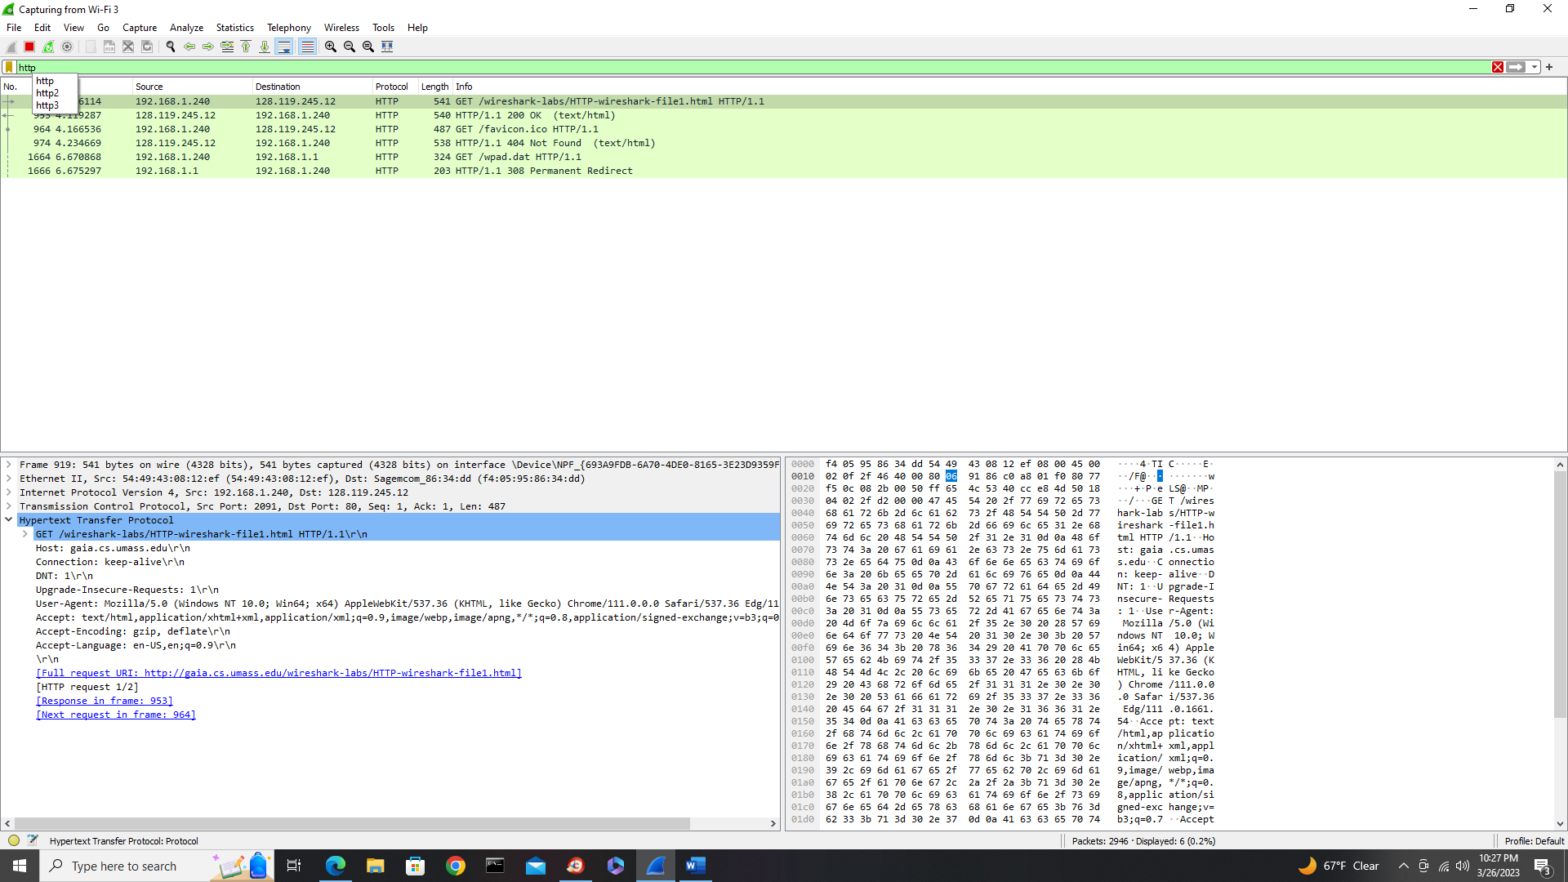

- HTTP version 1.1 is the version the browser is running. The server is running Apache/2.4.6.
- On the line “Accept-Language: “, the language accepted is en-US.
- The IP address of my computer under “source” from the capture window is 192.168.1.240.
- The status code returned from the capture windows under Info of No.31 was “200 OK”. 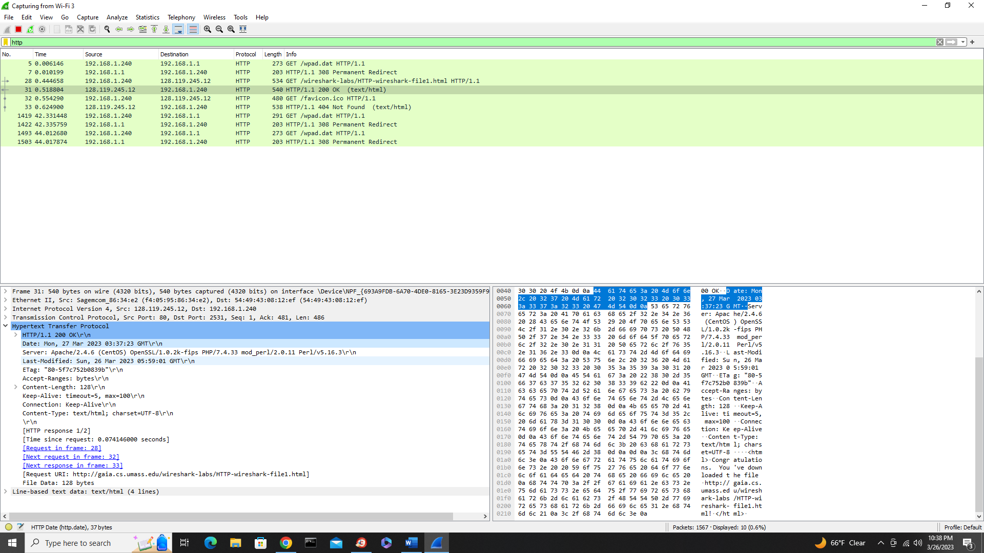
- The file was last modified: Sun, 26 Mar 2023 05:59:01 GMT
- 128 bytes of “File Data” were returned to my browsers.

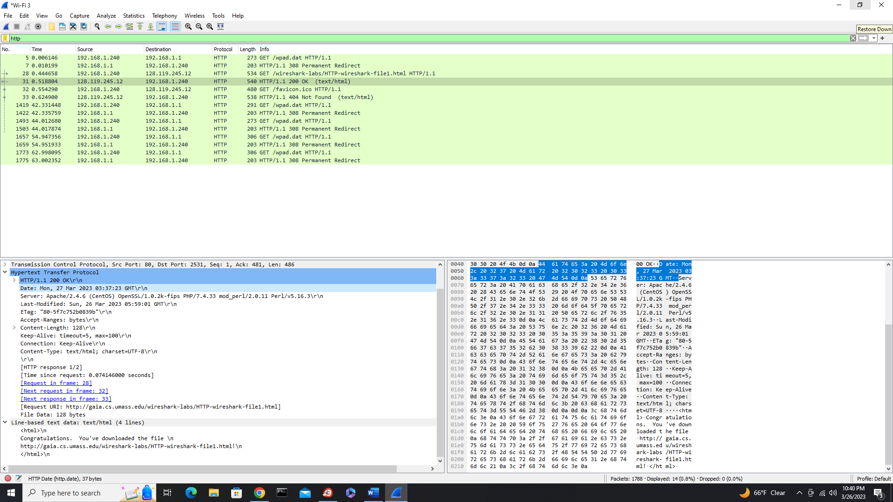
- No, I don’t see any headers from the raw data that aren’t displayed in the packing window.

Questions 8 – 11
http://gaia.cs.umass.edu/wireshark-labs/HTTP-wireshark-file2.html
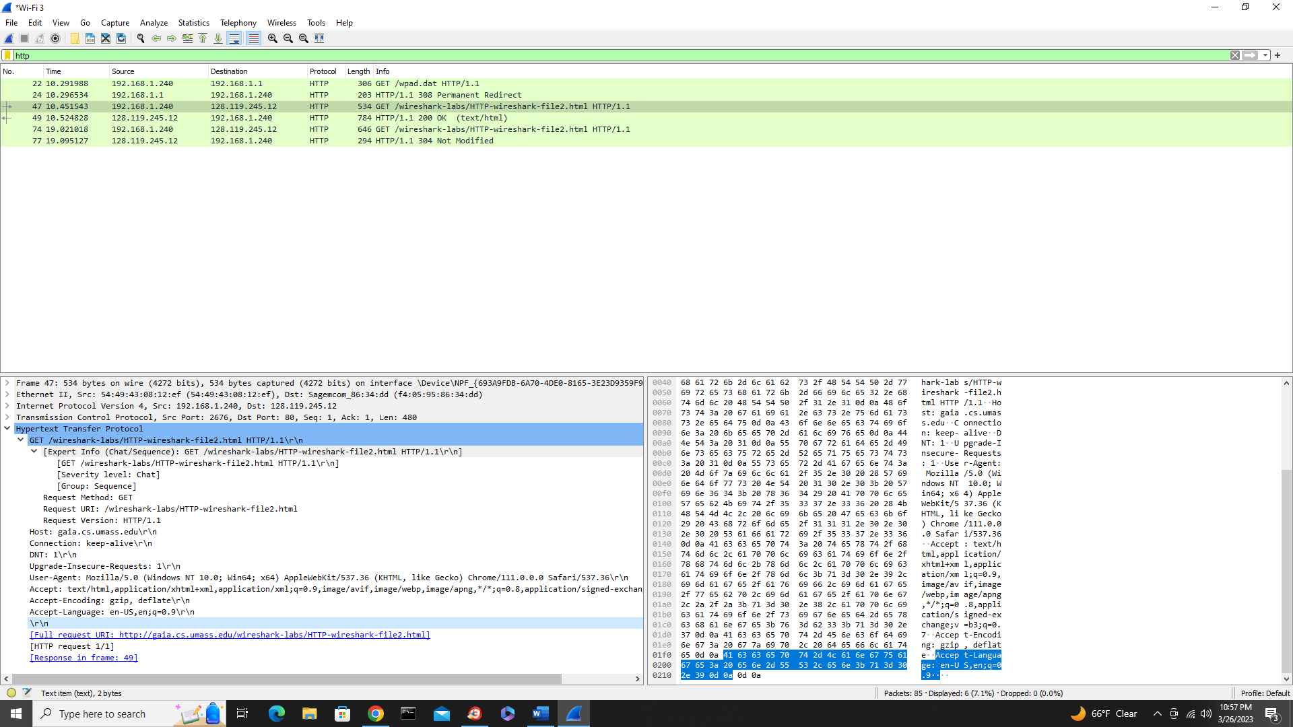
- No, I didn’t see anything that said “IF-MODIFIED-SINCE” in the first HTTP GET.

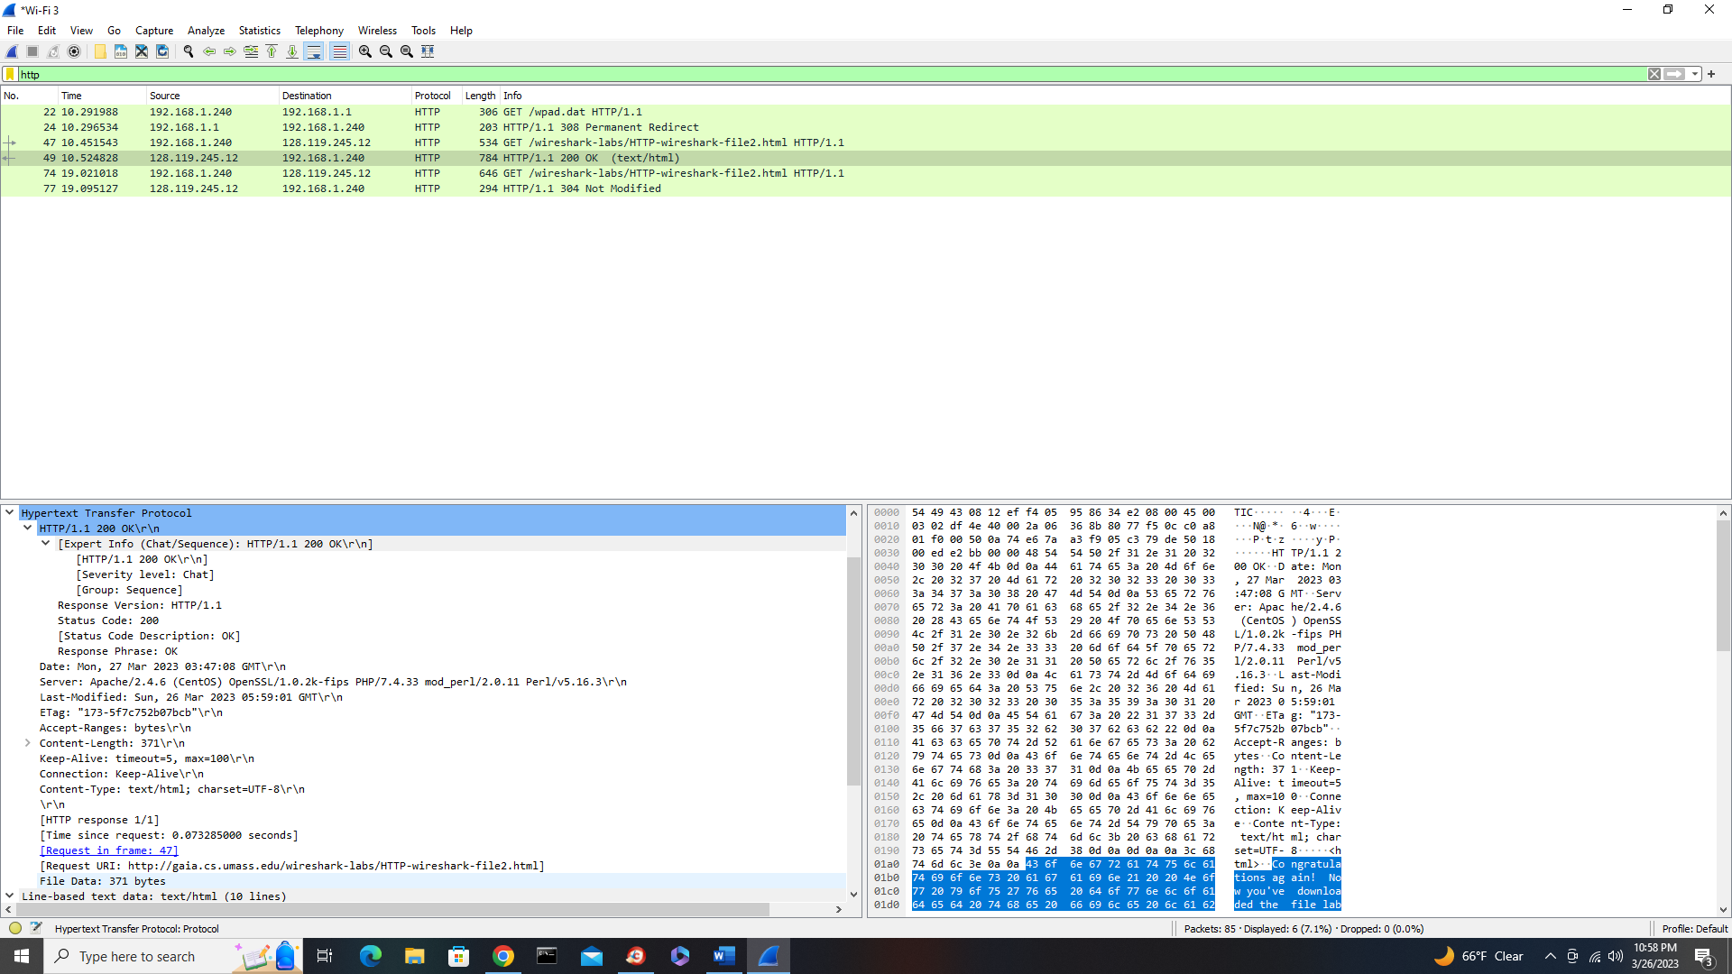
- Yes, I can tell the file was sent back by the file data sent back.
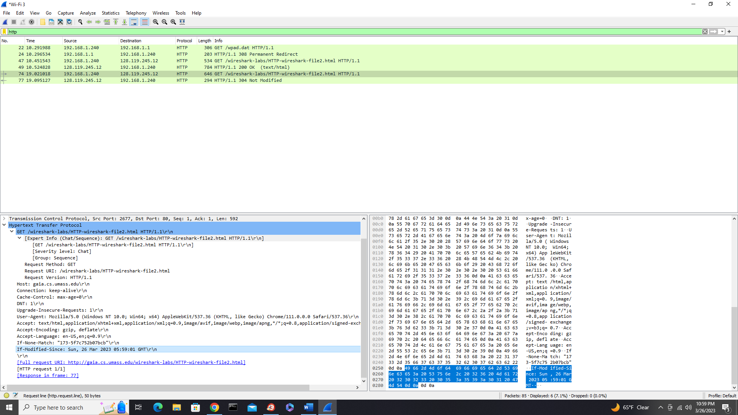
- Yes, and the line says “If-Modified-Since: Sun, 26 Mar 2023 05:59:01 GMT”.
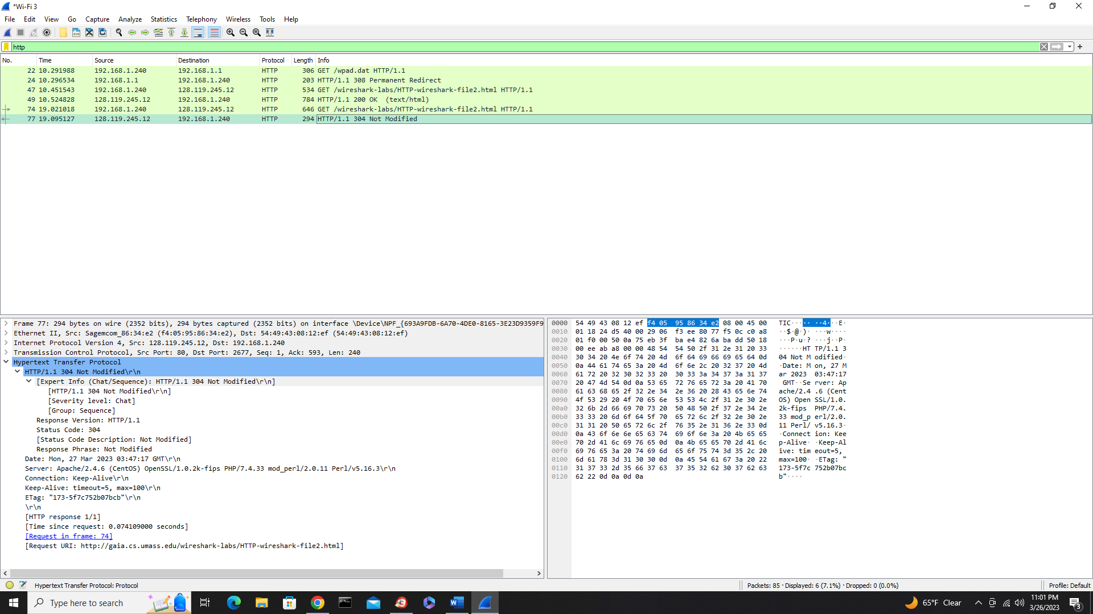
- The HTTP status code is “304 Not Modified”. The server didn’t return the content of the file as there was no data returned. By checking the heading date, it was understood that no data was changed on the site and so it returned the same information.

Questions 12 – 15
http://gaia.cs.umass.edu/wireshark-labs/HTTP-wireshark-file3.html

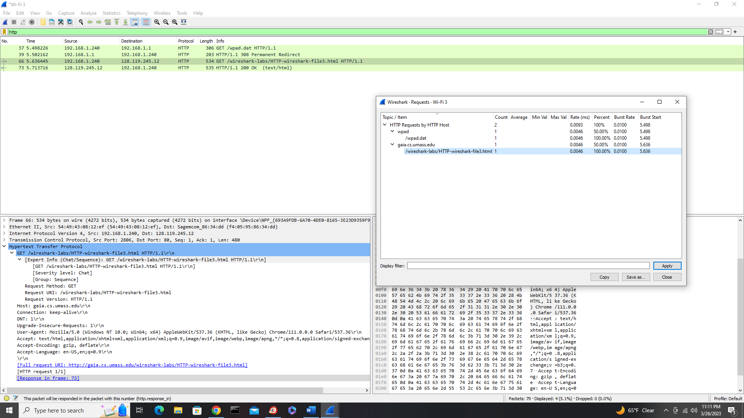
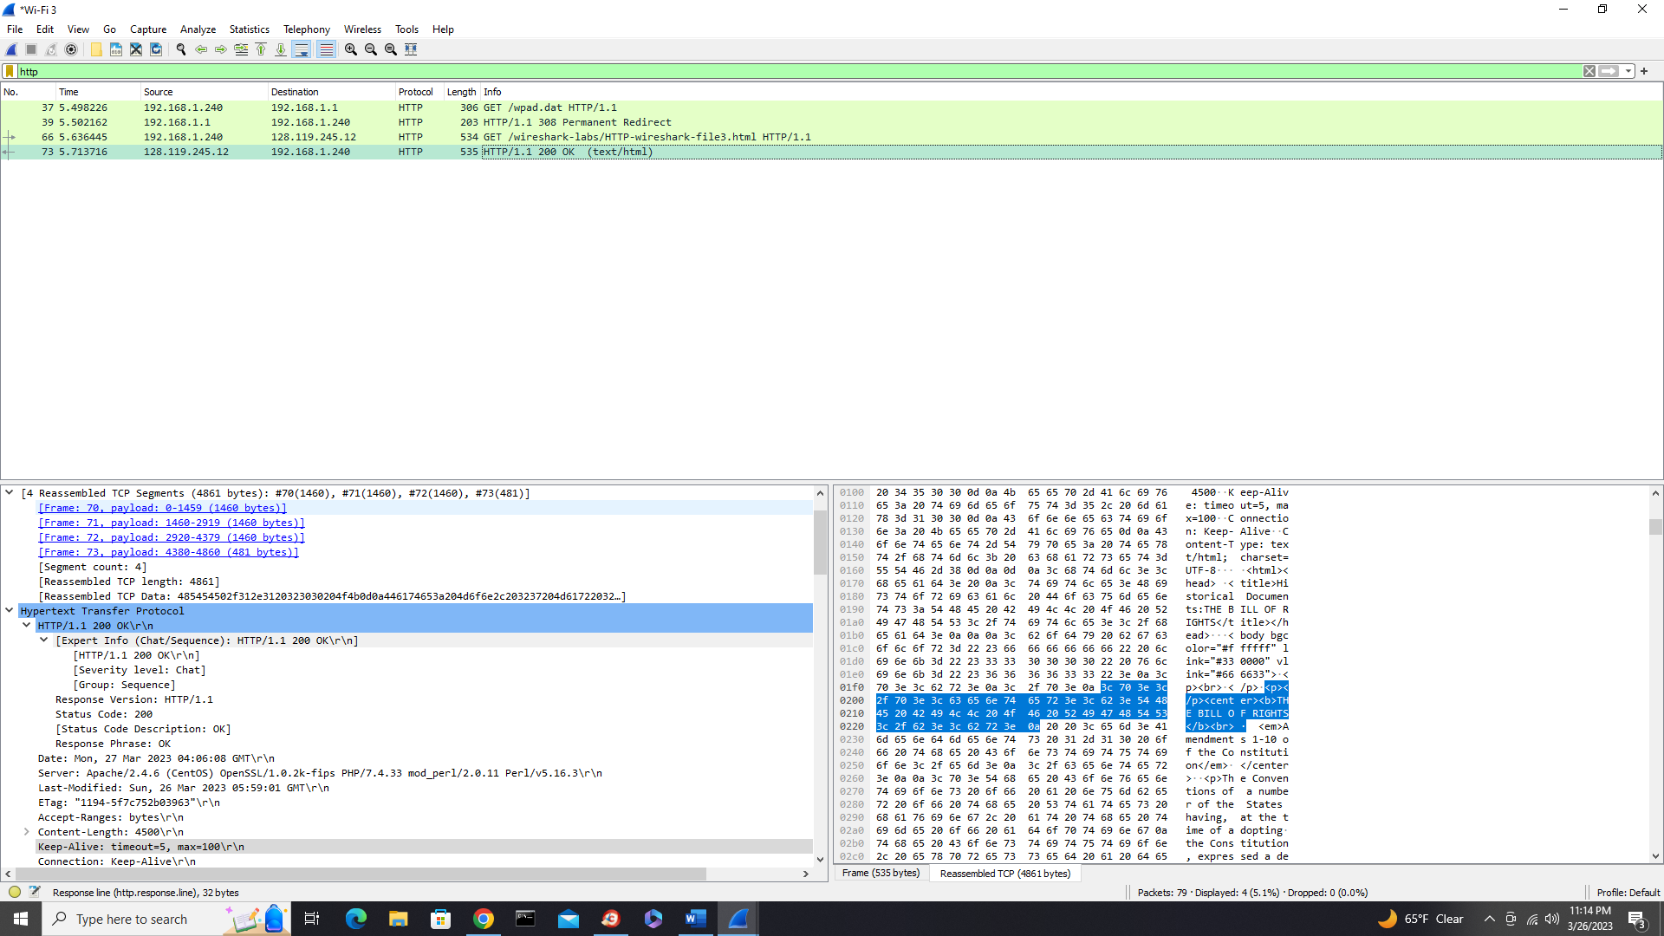
- Only one request message was sent, so the packet number in the trace was packet number 70.
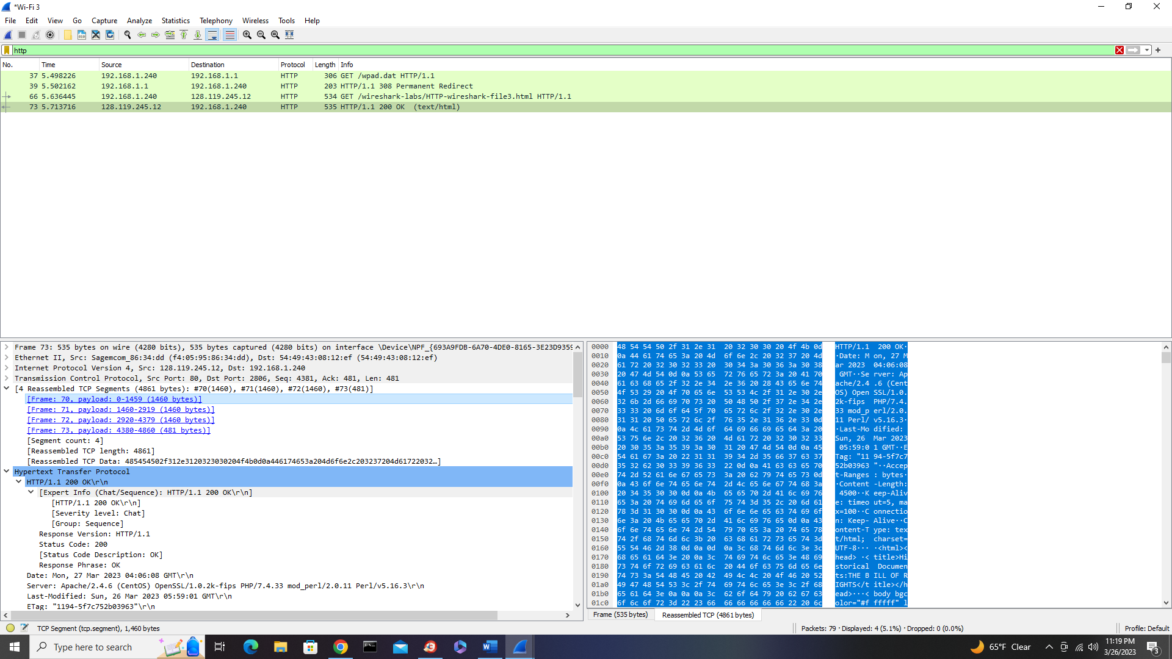
- The packet with the response is the beginning packet, packet 70.
- The status code and phrase are 200 OK.
- There were four TCP segments needed to carry the single TTP response and the text of the Bill of Rights.

Questions 16 – 17
http://gaia.cs.umass.edu/wireshark-labs/HTTP-wireshark-file4.html

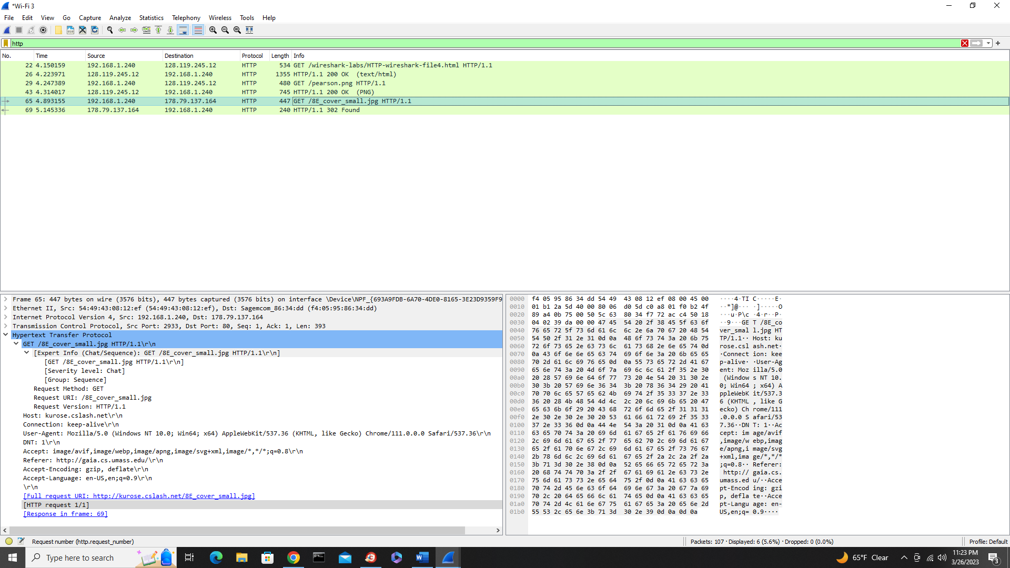
- There were three GET request messages that my browser sent. The internet addresses for the first two were the same, but the third was different (128.119.245.12, 178.79.137.164).
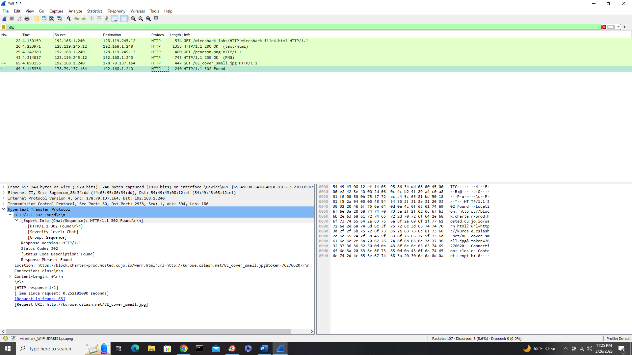
- It can’t exactly be told if the two images were downloaded serially or not, because there’s no dating for the second image. Instead, it has a time since the request, but not a time for when this image was requested to compare the first image.
Questions 18 – 19
http://gaia.cs.umass.edu/wireshark-labs/HTTP-wireshark-file5.html
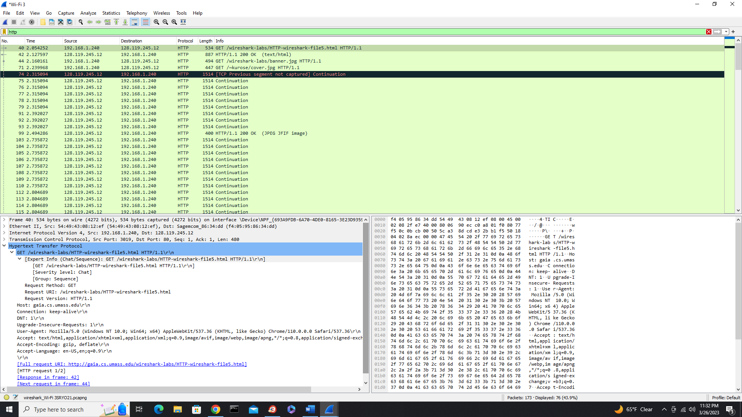
- The initial response from the get is 200 OK on No. 42.
- The new response from the second is a continuation with no status code.

